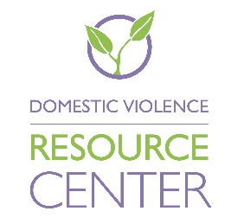

Position Title: Community Advocate (Bilingual: English/Spanish)
Program: Community Advocacy
Reports to: Lead Community Advocate
Supervises: n/a
Status: Non-exempt, Full-time.

Scope of Duties:
The Community Advocacy Program provides a wide range of services including assistance in obtaining a protective order, courtroom advocacy, safety planning, outreach, information and referral and short- term case management. The Community Advocate will be stationed at DVRC’s Hillsboro, Oregon location.

Responsibilities:
- Maintain an active knowledge of the protective orders for intimate partner violence
- Assist clients in filing paperwork for protective orders
- Notarize documents/petitions for clients
- Turn in completed protective order petitions to courthouse
- Attend petition review court hearing(s) for protective orders when appropriate
- Refer clients to other DVRC services and community resources
- Record, organize and submit monthly program statistics
- Review incoming police reports, assess risk, call listed victims in reports to offer and provide services and referrals
- Adhere to the programs and agencies policies and procedures
- Provide educational outreach regarding domestic violence and DVRC community advocacy when requested
- Maintain a positive relationship with court staff and outside partnering agencies
- Attend and participate in relevant community meetings and committees
- Assist clients in applying for the Address Confidentiality Program
- Provide relevant training for new staff and volunteers working in the Community Advocacy Program
- Other duties as assigned

Qualifications:
- Bilingual/Bi-literate: Fluent in English and Spanish required, bicultural preferred
- Experience working with the Latin@ community and has an understanding of Latin@ culture
- At least one year of experience in the field of domestic violence services
- Demonstrate knowledge and understanding of the dynamics in Intimate Partner Violence.
- Bachelor’s Degree (BS/BA) required or equivalent work experience
- Working knowledge of computers - Word, Excel, Power Point, email, internet
- Excellent organizational and time management skills
- Demonstrate knowledge and understanding of the dynamics in Intimate Partner Violence
- Ability to provide strong leadership in crisis situations.
- Knowledge of local domestic violence, sexual assault, dating violence, stalking and social service organizations in Washington County
- Ability to communicate effectively with clients and colleague’s
- Experience working with hostile clients
- Ability to assist clients regardless of sex, gender, sexual orientation, race, ethnicity, socioeconomic status, age, or disability
- Must complete the 40-Hour Victims’ Advocacy Training (required by State of Oregon) within a reasonable amount of time following the hire date.
- Ability to pass a background check

