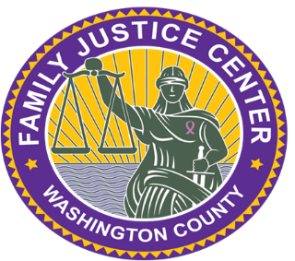

Family Justice Center of Washington County

Executive Director Position Description

The Family Justice Center of Washington County (FJC) provides a welcoming, collaborative space for survivors of domestic violence and their children to receive a wide range of services in one location to help them find hope and healing. FJC is a multi-agency, multi-disciplinary Center designed to provide comprehensive and coordinated services. The organization, founded in 2015, is seeking its first Executive Director.

The Executive Director will have overall management responsibility for FJC’s services and activities, including ongoing funding, development and maintenance of collaborative relationships, leadership in advancing FJC’s mission and vision, fiscal management, and facilitating inclusive and comprehensive service delivery to survivors.

This position requires excellent communication, interpersonal, organizational, conflict resolution, and leadership skills. The Executive Director will work both independently and in collaboration with FJC partners, and under the leadership of FJC’s Board of Directors. The position requires extensive knowledge of domestic violence issues, trends, and best practices in the field.

Job Location

The new Family Justice Center of Washington County will be located at 735 SW 158th in Beaverton Oregon.

Essential Functions

Establishment and maintenance of strategic partnerships with nonprofit, religious, and government agencies

Frequent communication with partners, survivors, community members, Board members, government officials, and funders

Maintenance of relationships with national FJC leaders and colleagues

Development and evaluation of FJC programs and services

Development and implementation of FJC policies and procedures

Hiring and supervision of FJC staff

Budget development and management

Grant writing and other fund development

Administration of grants and contracts

Minimum Qualifications

Bachelor’s Degree (Master’s Degree preferred) in a relevant field

Demonstrated knowledge of domestic violence programs and services

Demonstrated ability to establish and maintain effective working collaborations with on-site and off-site partners, as well as with the community at large

At least five years of supervisory experience

Excellent written and oral communications skills

Demonstrated fund development success

Demonstrated ability to foster and drive a diverse collaboration

Flexibility and problem-solving capabilities

Successful candidate must submit to and pass a background check

Compensation

$80,000.00 per year, full time, benefits negotiable

How To Apply

Email a resume and cover letter describing why you want this job and why you think you are a good candidate to info@fjcwashco.org

Thank you.

