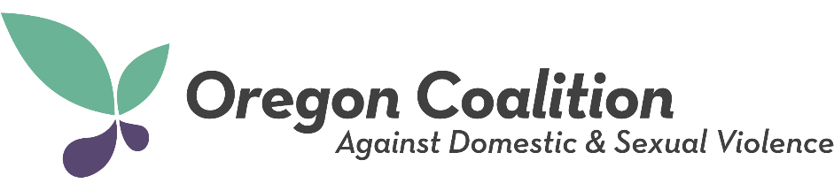

Photo Release
Each presenter must complete and submit this form.

Training: 2022 OCADSV Annual Conference
Location: Sunriver Resort (Sunriver, Oregon)

I grant to the Oregon Coalition Against Domestic & Sexual Violence, its representatives and employees the right to take photographs and video of me and my property in connection with the above-identified subject. I authorize the Oregon Coalition Against Domestic & Sexual Violence, its assignees and transferees to copyright, use and publish the same in print and/or electronically.
I agree that the Oregon Coalition Against Domestic and Sexual Violence may use such photographs and video of me with or without my name and for any lawful purpose including for example such purposes as publicity, illustration, advertising, and web content.

I have read and understand the above:

Signature: _______________________________________________

Typed or Printed Name: ____________________________________

Organization: _____________________________________________

Email: ___________________________________________________

Date: _________________

Signature of parent or guardian (if under 18):
____________________________________

