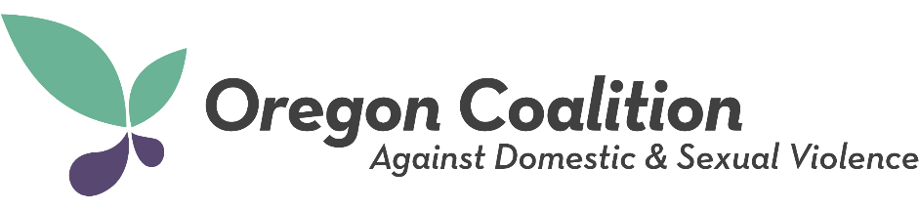
Release of Information
Each presenter must complete and submit this form.

Training: 2022 OCADSV Annual Conference
Location: Sunriver Resort (Sunriver, Oregon)

I grant to the Oregon Coalition Against Domestic and Sexual Violence, its representatives and employees the right to use the presenter biography and workshop description submitted by me in connection with the above-identified subject. I authorize the Oregon Coalition Against Domestic and Sexual Violence, its assignees and transferees to copyright, use and publish the same in print and/or electronically.

I have read and understand the above:

Signature: _______________________________________________

Typed or Printed Name: ____________________________________

Organization: _____________________________________________

Email: ___________________________________________________

Date: _________________

Signature of parent or guardian (if under 18):
____________________________________

